**IQ: How To Highlight Element Using Selenium WebDriver**

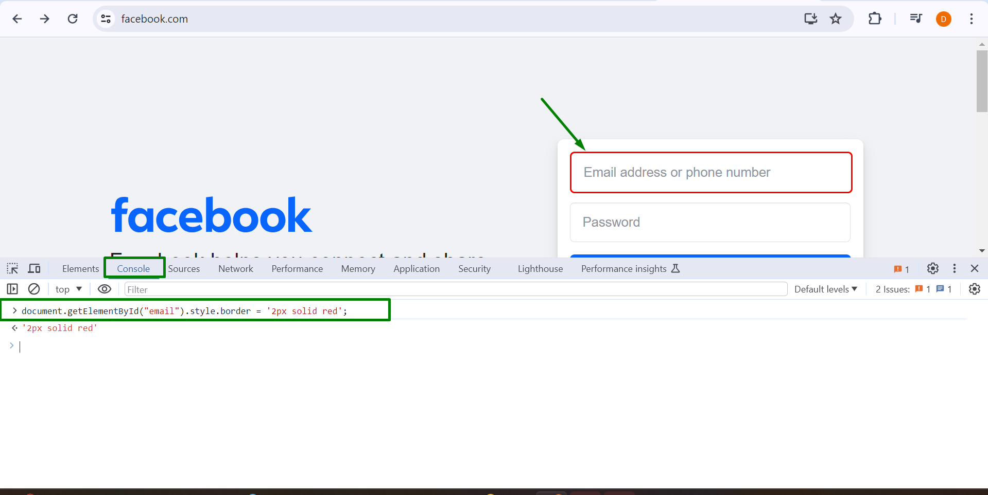

**document.getElementById("email").style.border = '2px solid red';**

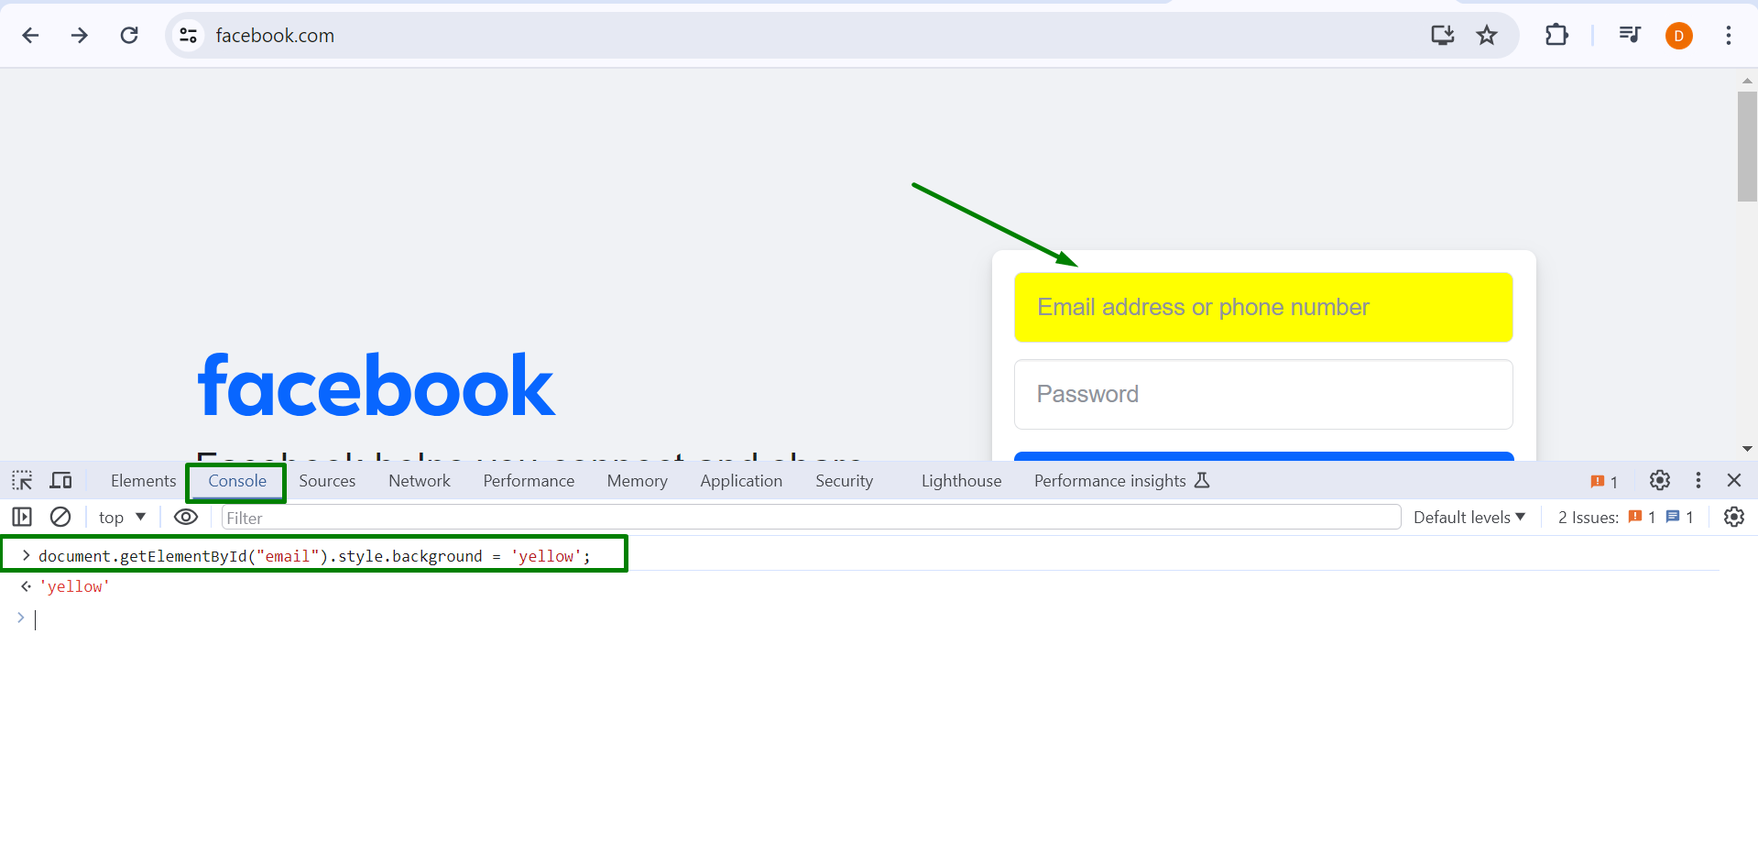

**document.getElementById("email").style.background = 'yellow';**

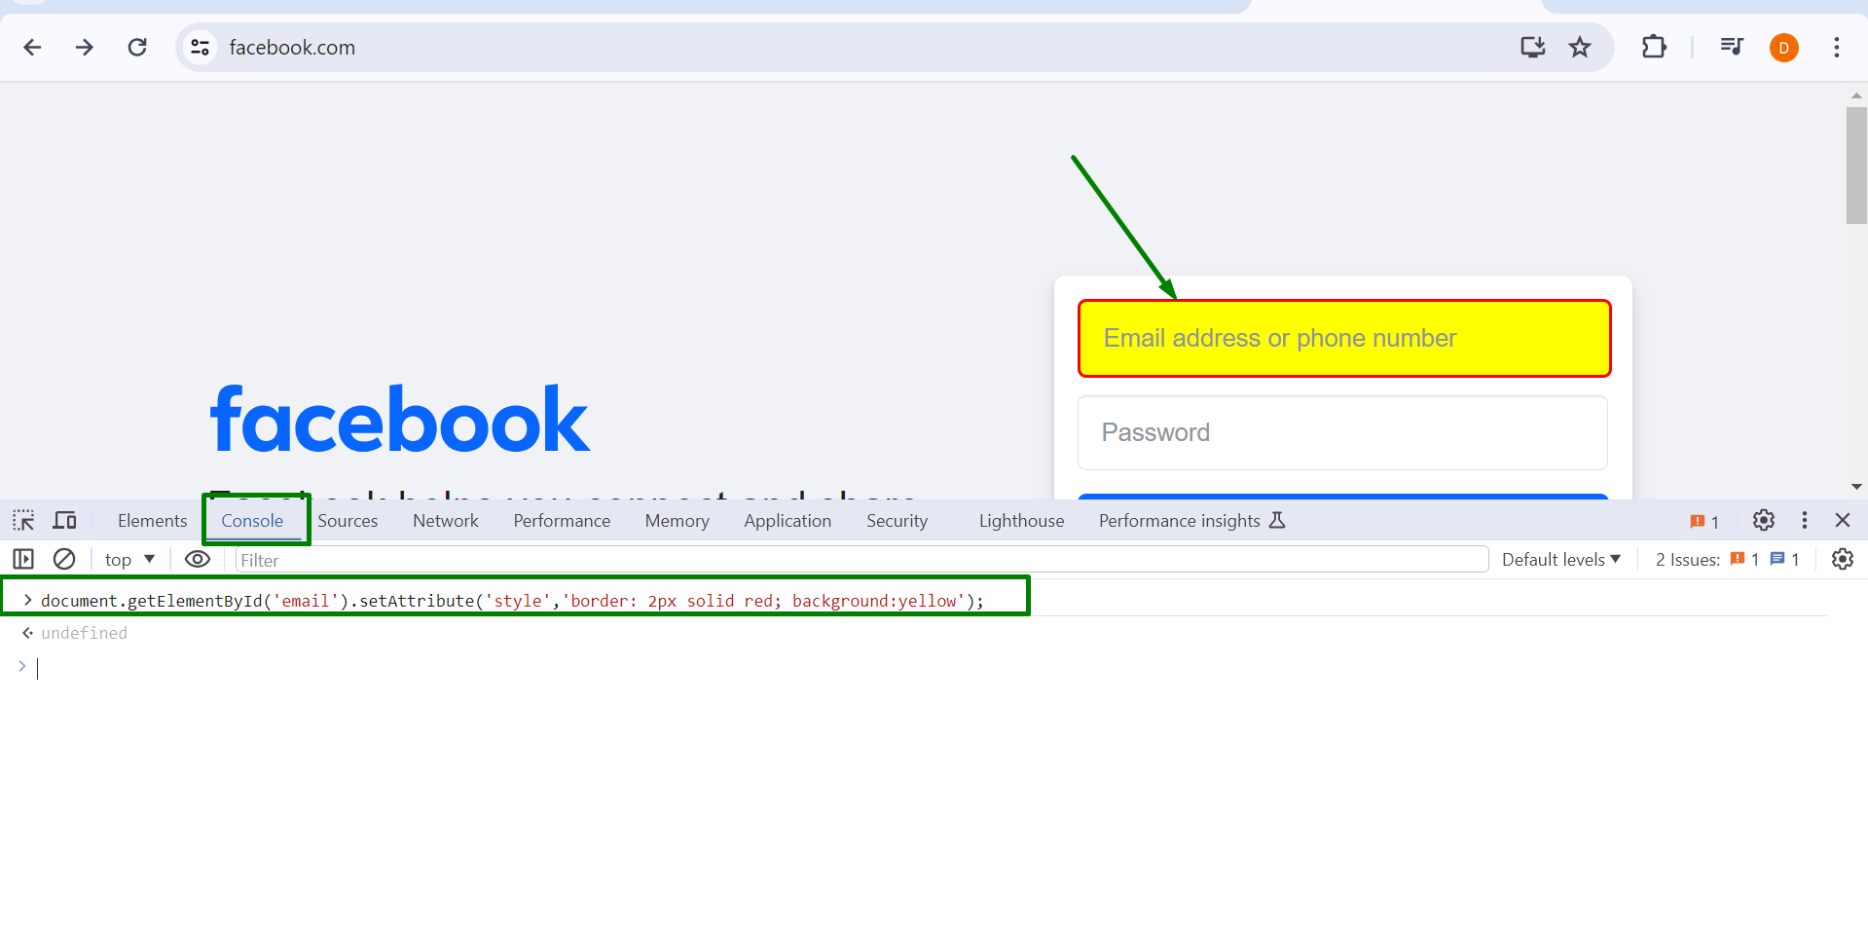

**document.getElementById('email').setAttribute('style','border: 2px solid red; background:yellow');**

**Program**

//IQ : How to Highlight Element in Selenium

**package** practice;

**import** org.openqa.selenium.By;

**import** org.openqa.selenium.JavascriptExecutor;

**import** org.openqa.selenium.WebDriver;

**import** org.openqa.selenium.WebElement;

**import** org.openqa.selenium.chrome.ChromeDriver;

**public** **class** HighlightText {

**public** **static** **void** main(String[] args) **throws** InterruptedException {

System.*setProperty*("webdriver.chrome.driver", "D:\\chromedriver_win32\\New5\\chromedriver.exe");

WebDriver driver = **new** ChromeDriver();

driver.get("https://www.facebook.com/");

JavascriptExecutor jse = (JavascriptExecutor)driver;

// jse.executeScript("document.getElementById('email').style.border = '2px solid red';"); // make border

jse.executeScript("document.getElementById('email').style.background = 'yellow';"); //make Highlight

// jse.executeScript("document.getElementById('email').setAttribute('style','border: 2px solid red; background:yellow');"); // make border with highlight

// ------- way 2

// WebElement email = driver.findElement(By.id("email"));

// jse.executeScript("arguments[0].setAttribute('style','border: 2px solid red; background:yellow');",email);

// Thread.sleep(2000);

// jse.executeScript("arguments[0].setAttribute('style','border: ; background:');",email); //highlight disappear

}

}

**Output**

